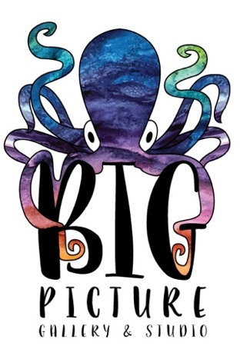
Big Picture Gallery & Studio Scholarship Application:
319-343-7240
www.bpgalleryandstudio.com
director@bpgalleryandstudio.com

185 Highway 965, Suite #3
North Liberty, IA 52317

Please complete and return this form by June 1st. Forms can be emailed to director@bpgalleryandstudio.com, or dropped off in person during our business hours, which are listed on our website.

Applicant’s Name: _____________________________________________________________

Applicant’s Age & Grade:_______________________________________________________

Parent’s Name: ________________________________________________________________

Parent Phone Number: _________________________________________________________

Parent Email: _________________________________________________________________

Annual Family Income: _________________________________________________________

Number of Family Members (including parents and all children): ____________________

To be completed by student applicant:
Please list your top 3 choices of camps and briefly describe why you would like to attend an art camp at Big Picture:

Student Signature___________________________________________ Date___________

Parent Signature___________________________________________ Date___________

